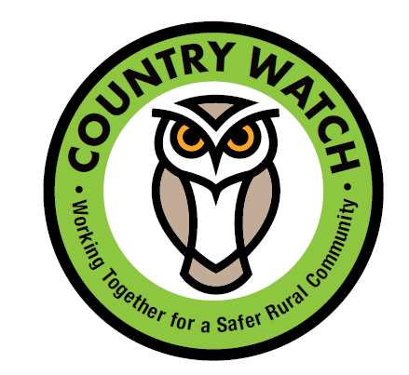

Dorset Police have launched the Country Watch Website, a one-stop rural resource centre for all things rural crime related in Dorset. #Country Watch
We are proud to support Country Watch and help Dorset’s residents overcome rural crimes.
Country Watch covers Fly Tipping, Rural Resources, Wildlife Crime and Heritage Crime.
Follow the link to the Country Watch Website:

http://www.countrywatchdorset.co.uk/

